**Phase – II**

**Practice Project – IV**

**Product Details**

**Sai Krishna Rajagopal**

**22-03-2022**

**GITHUB Repository URL:** [**https://github.com/SaiKrishna6699/JavaFSDTraining.git**](https://github.com/SaiKrishna6699/JavaFSDTraining.git)

**Technical Summary:**

1. **JSP**
2. **Java EE**
3. **Eclipse**
4. **Web Browser (Chrome)**
5. **MySQL**
6. **Tomcat 8.5**
7. **Git**
8. **JSP:**

JSP file named index.jsp is used to imbed html page with minimal CSS is created, which consists of a HTML Form takes input for the Adding Product.

1. **Java EE:**

The Product Details was developed in Java Enterprise Edition (Java EE) using the concept of Servlets.

The Application is fully Functional and Working Perfectly with No Exceptions.

Short Summary of Code:

* In this Application there is one Java Servlet for full functional working of the application.
* App.java is the java servlet created to print the product details for a product from JSP page

1. **Eclipse:**

Eclipse is the IDE used to Write the code. It is a very programmer friendly and easy to use application.

1. **Tomcat 8.5:**

Apache Tomcat is a webserver which is used to host web apps locally in the system. In this project Tomcat 8.5 is used to host the Servlet application. Tomcat 8.5 supports Java 7 and other latest versions of the Java EE.

1. **MySql:**

MySQL is an open-source relational database management system. It is structured query language created Oracle Corporation. Here MySql is used to connect database to eclipse using mysqlConnector jar file.

1. **Git & GitHub:**
   1. Git is the version control system used to store the data in a remote Repository.
   2. GitHub is the remote data base contains repository which is used to store the data.

Git Commands used:

$git init

$git remote -v

$git add .

$git commit -m “Adding PP3”

$git branch -M master

$git push -u origin master

1. Screenshots:

Output:

Index Jsp:

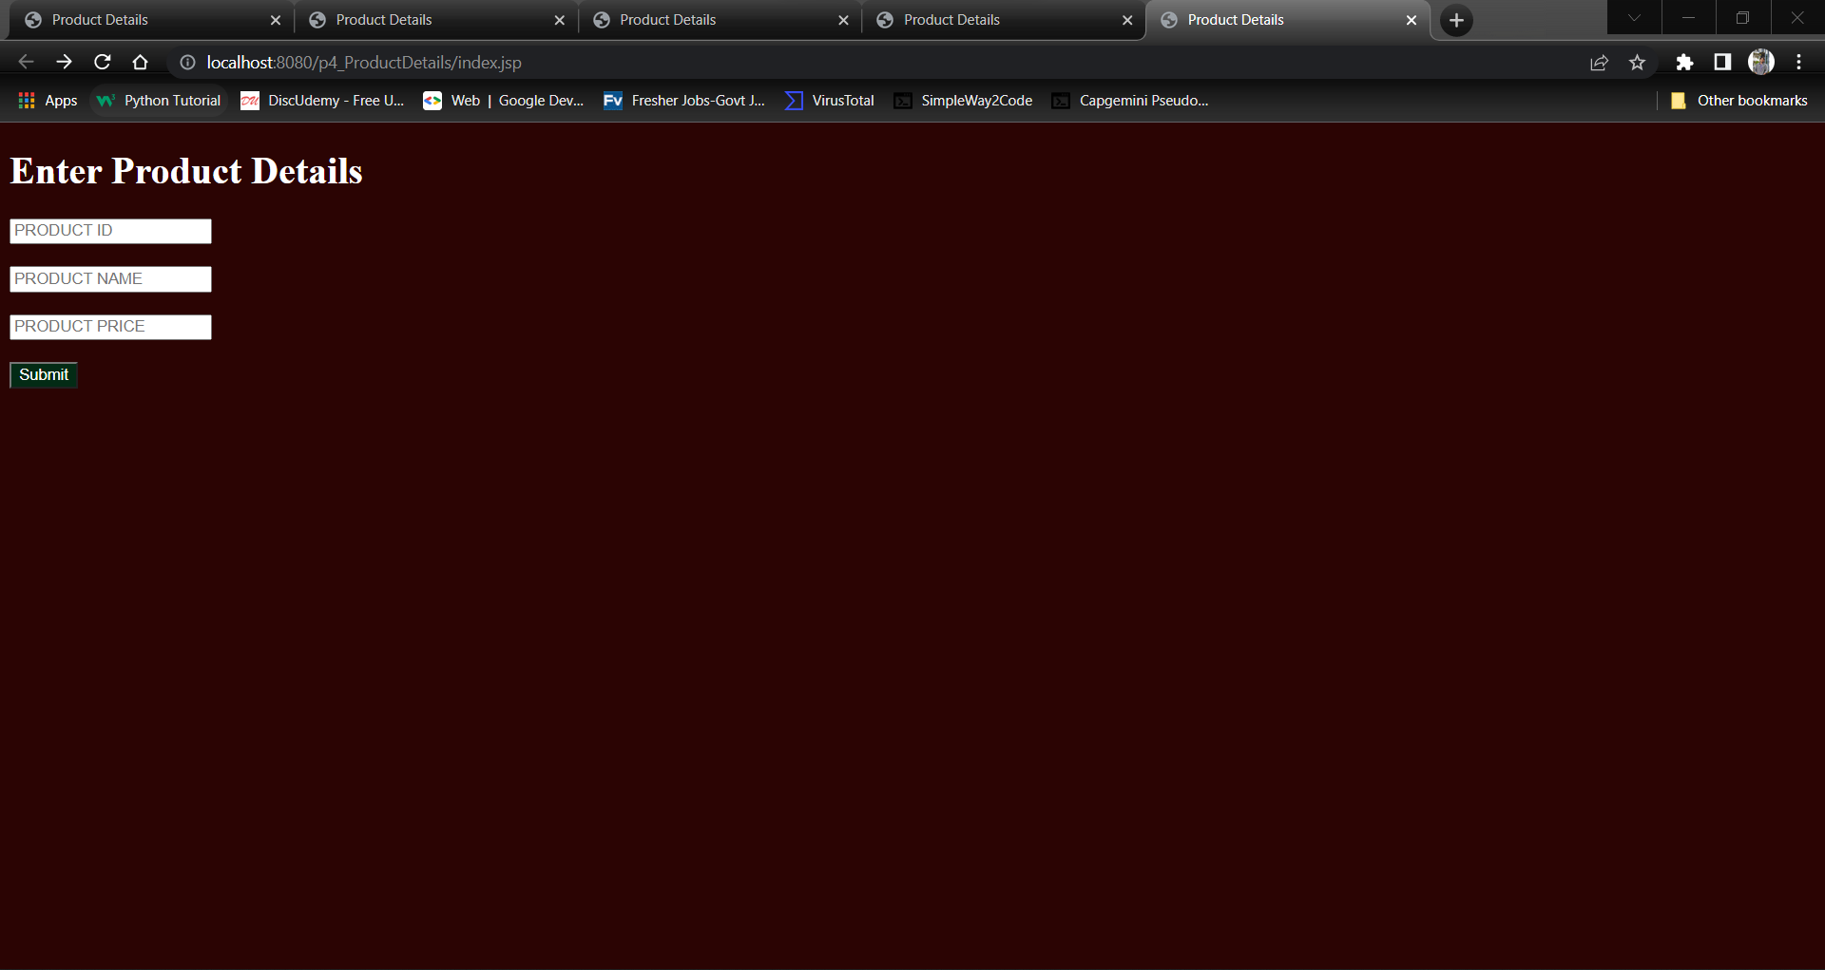

Display Jsp

Output1:

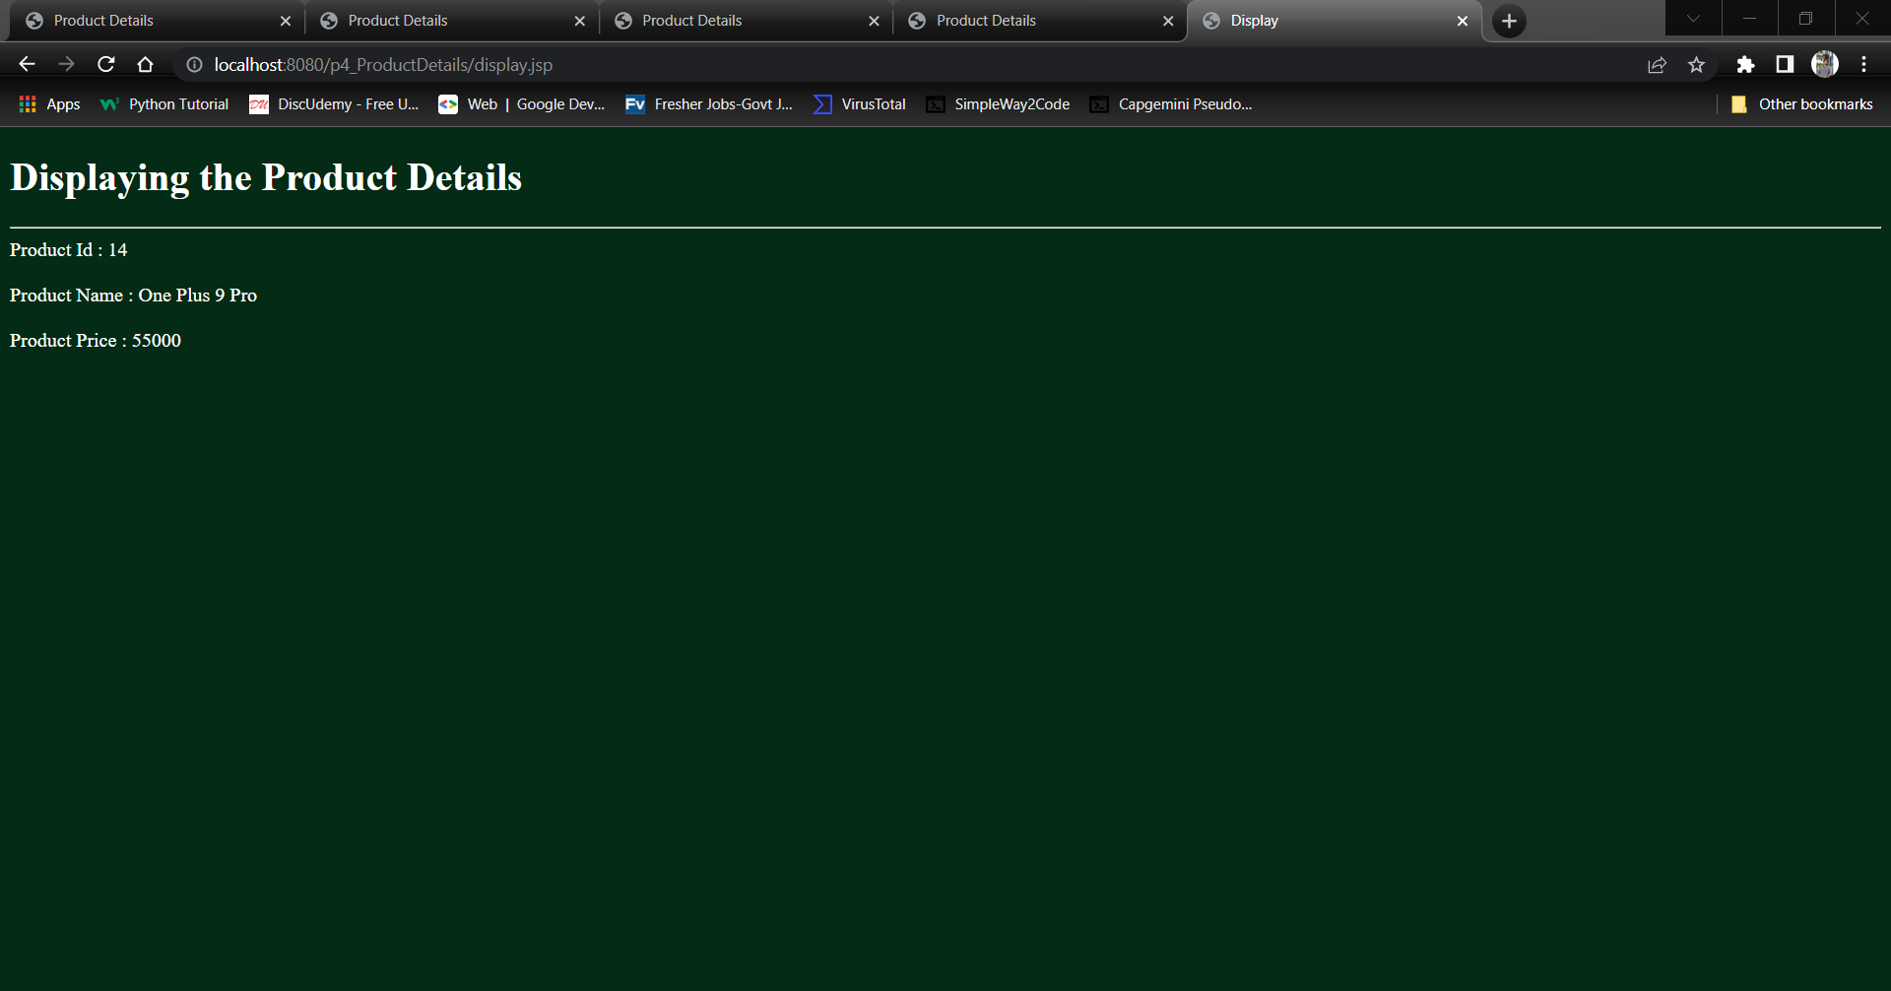

Git:

